

Scallywaggs

Graduation Kindergarten

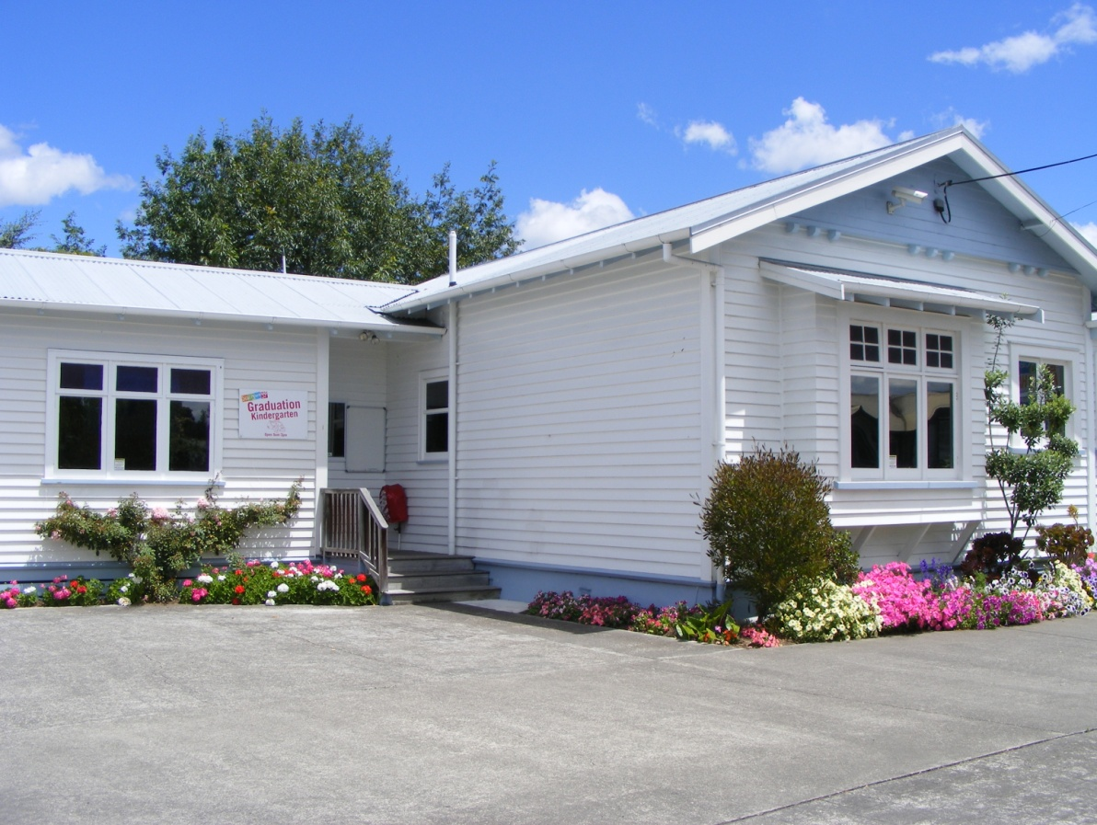

Parent Information Pack

Scallywaggs Kindergarten & Care **858 7404** –Cell Phone **027 7120 163** – Kids Club **858 7405**

Sprouts In-Home Childcare **0800 777 688** – [www.scallywaggs.co.nz](http://www.scallywaggs.co.nz)

9 Russell Street, Waipukurau, 4200

**Kia Ora and Welcome to Scallywaggs Graduation Kindergarten**

We welcome you and your family/whānau to the Graduation Kindergarten and extend an open invitation to spend time with your child in our stimulating and safe learning environment.

This is a brief overview of a few routines and expectations that will support a smooth transition for your child to move on to school:

* Our programme operates between 9.00am and 3.00pm, however, Scallywaggs Kindergarten and Care is open from 7.30am – 5.30pm.
* If dropping your child off before 9.00am and picking up after 3.00pm, you must sign in and out on the white sheet in the Main House just outside the office door. If dropping your child off between 9.00am and 3.00pm, you need to come straight to the Graduation Kindergarten and sign your child in and out on the yellow sheet. Kaiako from the Graduation Kindergarten are required to supervise in other areas at 3pm so there will be no children in the Graduation building after this time.
* Scallywaggs supplies morning and afternoon tea and this consists of sandwiches and fruit. Children are encouraged to eat from their lunchbox first at afternoon tea time.
* Please supply your child’s lunch in a named lunchbox and a **water** filled, named drink bottle (children have access to drinking fountains). We encourage healthy eating and children are asked to choose sandwiches or fruit from their lunch boxes first.

Scallywaggs is **nut free**!This includes all nut products including nuts, peanut butter and Nutella.

* We appreciate your support by not sending lollies/roll-ups/chocolates in your child’s lunchbox. High sugar treats will be returned home in lunch boxes.
* Please send your child with an adequate amount of **named** spare clothing and a plastic bag. Exploring with water, sand, clay, paint and messy play means clothing can often become wet or dirty. If this is a concern, please discuss it with the Head Teacher.
* We often go on walks within our local community so it is important that your child has good walking shoes.
* Toileting – please talk to the kaiako if your child needs extra support with toileting.
* Any information for you or your tamariki will be placed on the whiteboard at the entranceway or notices will be placed in your child’s bag. Please check these areas daily.
* Please check the children’s art box regularly and take your child’s precious art home.
* Your child’s profile book is available for you to share with your child at the centre or take it home to share with families. It will be presented to them to keep or pass on to their New Entrance kaiako on their 5th birthday. Please tell the kaiako if you want to take your child’s profile book home for reading. Your child’s profile book needs to be returned to the kindergarten however so we can continue to add examples of your child’s learning.
* Graduation ceremony: We acknowledge this is a very special time for your tamariki. We make their graduation all about them. This day and time is chosen by you and your whānau. During the ceremony we share their Learning Journey with the class and whānau. Your tamariki is given a gift from Graduation Kindergarten to support them on their school journey. You are free to bring in a treat to share with the children at the end of the ceremony.
* We have an open door communication ‘policy’. Our teaching team welcomes parents, caregivers, families/whānau to chat and share information about your child’s learning and development any time.
* Formal information sharing time can be arranged with the Head Teacher if you have any queries and/or concerns.
* We welcome and value your support sharing knowledge and working together with us in partnership to enhance your child’s holistic learning and development.
* Please write any special daily requirements on the sign-in sheet or let the kaiako know on the day.
* Please ensure written permission in our medication folder is given for us to give any medicine your child requires while at the kindergarten. **This is a legal requirement that we must have on our records.**
* We undertake internal review on a regular basis to ensure we are meeting the needs of children, families, and the community as well as regulation requirements. We invite and encourage you to be actively involved in this process.
* We invite you to participate and contribute in our policy review process. We review different policies monthly. The policies due for review are listed in the monthly newsletter and are available at the office foyer.
* Graduation Kindergarten surveys will be sent home with your child from time to time.
* Scallywaggs receives funding from the Ministry of Education and the record of spending is displayed on the parent notice board.
* The latest ERO report is available on our website www.scallywaggs.co.nz

**We look forward to having you and your child/children in our kindergarten.**

Graduation Kindergarten Fees

* Booked hours - $5.60 per hour
* Casual hours - $7.50 per hour
* 20 ECE hours - No Charge

All fees are required to be **paid one week in advance** to cover the current week. The first fee payment is required before care commences. We encourage fees to be paid weekly by Automatic payment, Internet banking, or Telephone banking; however we do accept Eftpos, cash or cheque through the office.

Scallywaggs Kindergarten & Care account details are:-

BNZ Waipukurau **02 0780 0033099 03**



GMA5

**Scallywaggs Kindergarten & Care**

**Philosophy**

At Scallywaggs we value the diversity of our families and aim to develop respectful partnerships where cultures, values and aspirations are acknowledged.

Our passionate kaiako pride themselves in offering an environment that is welcoming, fun, nurturing and stimulating. Each child is unique and as such we provide a program which will support and celebrate their individual milestones, strengths and emerging skills.

Strong attachments are formed with every child enabling the opportunity for children to develop confidence, independence and resilience through play based learning opportunities. Successful transitions are supported between centres when children are developmentally ready.

Revised October 2016, revised March 2018

Graduation Kindergarten Daily Programme

9.00am Graduation Kindergarten opens and the programme commences.

Children are supported and encouraged to take responsibility for putting their bags and lunch boxes in the correct area.

Encourage/support children to engage in learning experiences based on emerging interests, available inside or outside. This may include being involved in the setting up process.

Kaiako to support children by providing safe and stimulating resources, use timely intervention, engaging children in meaningful conversations and interactive sustained play.

10.00am Morning tea (provided) sandwiches and fruit. All children to eat together and are supported to wash hands and sit when eating.

We regularly provide children with the opportunity to make/bake or be involved in their own morning tea.

12.00pm Group time: Children are encouraged to participate and explore group learning experiences/activities like books, music and movement, letter phonics, early maths concepts and classroom routines.

12.20pm Lunch time karakia.

Lunch time – encourage independence, role model good eating habits and social skills at meal times.

12.50pm Children encouraged to engage with books.

1.00pm Free play Kaiako to support children by providing safe and stimulating resources, use timely intervention engaging children in meaningful conversations and interactive sustained play.

2.15pm Pack up time, both inside and outside, Children are encouraged to be responsible for their play.

2.30pm Children to come into group time where their personal belongings are put on or away.

2.40pm Afternoon tea.

2.55pm Pack up ready for parents, or children who are booked in after 3pm go to Middle Kindergarten.

3.00pm Graduation Kindergarten closes.

Revised in February 2019