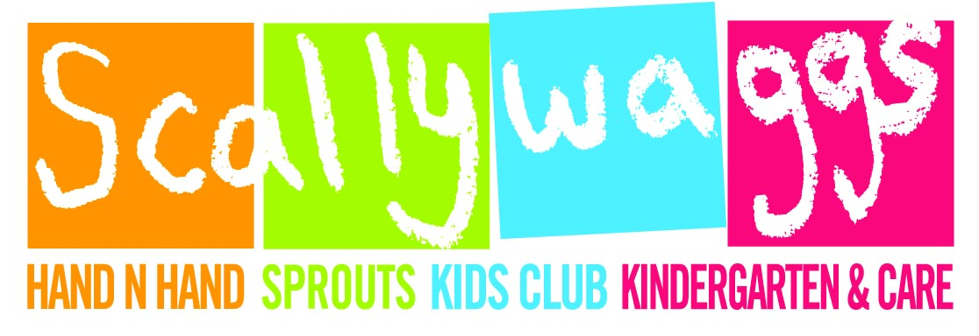Scallywaggs

Middle Kindergarten

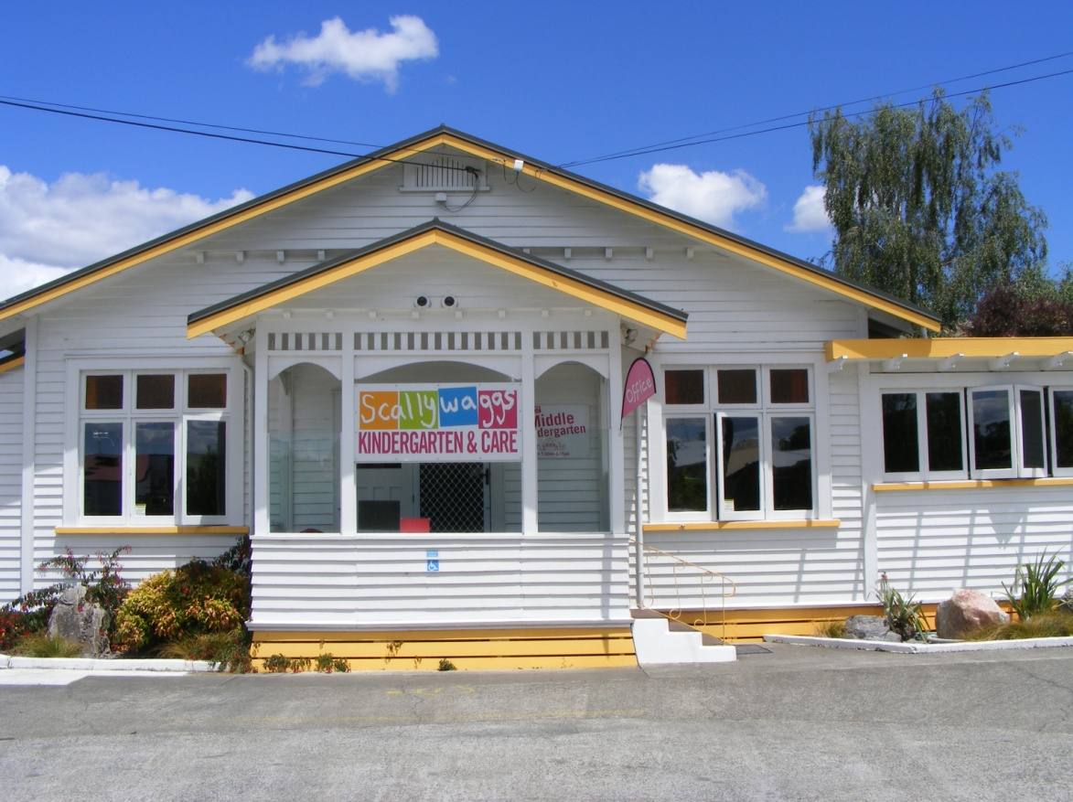

Parent Information Pack

Scallywaggs Kindergarten & Care **858 7404** –Cell Phone **027 7120 163** – Kids Club **858 7405**

Sprouts In-Home Childcare **0800 777 688 –** [www.scallywaggs.co.nz](http://www.scallywaggs.co.nz)

9 Russell Street, Waipukurau, 4200

**Kia Ora and welcome to Scallywaggs Middle Kindergarten**

We extend an open invitation to parents and caregivers to spend as much time as you wish with your child in this exciting learning environment. The Middle Kindergarten teaching team are there for you whenever you need us. Please don’t hesitate to call on us for assistance where needed.

**Here are a few tips that will help you settle into our centre:**

* Your child needs to be signed in and out, with your signature, on the orange sheet every day.
* Our programme operates between the hours of 9am and 3pm, however Scallywaggs Kindergarten & Care is open from 7:50am – 5:15pm.
* **Named Belongings** - Please ensure that your child’s belongings, including bags, lunch box and drink bottles are clearly named. This will prevent items from becoming misplaced. Please name bags on the outside.
* **Positive Behaviour Strategies** – The Middle Kindergarten supports children to make good choices incorporating strategies from the Incredible Years. These strategies empower children to make positive and independent learning choices. There is detailed information on the parent noticeboard by the cubbies or feel free to ask a kaiako.
* **Healthy Heart –** Scallywaggs supports the healthy heart programme running in conjunction with Sport Hawkes Bay. We would appreciate your support in promoting health education to your child. Feel free to ask our team for any information you may need. There is a notice board with some information, please contribute or use any helpful ideas.
* **Drinks** – We only offer water at Scallywaggs so please supply a named drink bottle. Any other drink products will be returned home this includes flavoured milk drinks, up and go.
* **Food -** Scallywaggs is **nut free!** This includes all nut products including nuts, peanut butter and Nutella. We encourage healthy eating whereby the children choose 2 healthy choices from their lunchboxes first. All sweets or high sugar foods such as lollies, chocolate, strings, roll ups and similar will be removed and sent home.
* Scallywaggs supplies morning tea which consists of sandwiches and fruit. At afternoon tea, we encourage your child to eat from their lunch box unless it is empty, then we will offer fruit.
* **Lunchboxes** are stored in the cubby holes and drink bottles on the bench above the cubby holes. Again **ensure that your child’s belongings are clearly named.**
* If you require your child’s lunch to be heated, please supply the food in a microwave container for ease of heating. Please name yoghurts and put these on the tray on arrival. Ask the team if you need assistance finding things.
* Please send your child with at least **2 sets of spare named clothing** and a plastic bag. Children often have accidents or become wet or dirty through water, sand, paint and messy play.
* We may go on spontaneous walks into the community, so it is important that your child has **appropriate named shoes** to wear. Gumboots are recommended for the winter or wetter periods.
* **Toileting** – we will support your child to toilet train by reminding them at regular intervals. Please bring several changes of clothes, socks, wet wipes and plastic bags to support your child’s well-being during this process. Toileting is documented daily on a clip board in the bathroom.
* **Nappies** - If your child is in nappies or pull-ups, please supply enough for the day and some wet wipes. Ideally 3-4 nappies should be plenty.
* After lunchtime we provide a **sleep/rest time** and ask that you provide a **named sheet and blanket**. No pillows please. These are returned to you to be laundered at regular intervals. Wet or soiled bedding will be sent home on that day. Bedding is stored in cupboard near the kitchen. Sleep time is documented daily on a sleep chart with times of when your child fell asleep and awakens.
* **Artwork** created by your child will be stored in our art box. Please check it regularly and take home your child’s precious work.
* Your child’s **profile book** is available to them at all times so they can share their accomplishments with their peers, kaiako and family. Please feel free to sit with your child and look at their book. You are welcome to take your child’s profile book home to share with family; however it needs to be returned to the Centre within 7 days. Please sign it out in the book above the profile stand. Thank you.
* Please feel free to approach the teaching team at any time if you are unsure of anything, or have any queries or concerns. We are happy to address all matters and love to chat with our families and share your child’s day with you. Formal information sharing time can be arranged with the Head Teacher if you have any queries and/or concerns at a mutually agreeable time. The Head Teacher will set a plan with you when settling your child to ensure their needs are respected.
* **Planning –** our programme is planned according to individual children’s needs. The weekly planning is visible on the Middle Kindergarten Staff room door. Please feel free to add your voice to our programme.
* As a centre we undertake **self review** on a regular basis to ensure we are meeting the needs of our children, families, the community and any legislative requirements. Please see our planning sheet to find out the latest self review. If you have anything to share, please make some notes or speak to a team member.
* A Middle Kindergarten **survey** will be sent home with your child from time to time.
* **Policies, procedures and philosophy** – These are legislative requirements set out by the Ministry of Education. You can review the policies at any time while at the centre. We invite you to participate in our review process which takes place monthly. The policies due for review are listed in the monthly newsletter and are available at the front office or in the Middle Kindergarten. Please discuss with Head Teacher.
* Scallywaggs receives **funding from the Ministry of Education**, details of this spending is displayed on the parent notice board in the main office foyer.
* In this pack there is an “**all about me sheet**”. This information helps us to understand each child enabling us to develop a stronger relationship with your child. It is important that we are aware of your family values, beliefs and culture, as well as each child’s individual strengths and interests. Please fill this out and return it with your enrolment form. Please feel free to share your aspirations for your child whilst they are in our centre.
* You will be kept informed of centre happenings through a monthly newsletter and on the notice board in our room. The newsletter is available online at [www.scallywaggs.co.nz](http://www.scallywaggs.co.nz) or hard copy. We encourage you to respond to any issues raised through the suggestion box located in our room.
* We can provide you with parent support and education opportunities, such as Public Health Nurse, Specialist Education Services, Dental Nurses, and Local Parenting Workshops. Parents also have access to our resource library containing magazines and books.
* A copy of the latest ERO report is available to read in the main office foyer.

**IF YOU ARE NOTIFIED OF AN EVACUATION THE DESIGNATED SAFE AREA FOR YOUR CHILD IS IN THE PADDOCK. PLEASE MAKE YOUR SELF FAMILIAR WITH THIS AREA AND DISCUSS WITH HEAD KAIAKO IF ANY QUERIES.**

Middle Kindergarten Fees

* Booked hours - $5.50 per hour
* Casual hours - $7.50 per hour
* 20 ECE hours - No Charge

All fees are required to be **paid one week in advance** to cover the current week. The first fee payment is required before care commences. We encourage fees to be paid weekly by Automatic payment, Internet banking, or Telephone banking; however we do accept Eftpos, cash or cheque through the office.

Scallywaggs Kindergarten & Care account details are:-

BNZ Waipukurau **02 0780 0033099 03**



GMA5

**Scallywaggs Kindergarten & Care**

**Philosophy**

At Scallywaggs we value the diversity of our families and aim to develop respectful partnerships where cultures, values and aspirations are acknowledged.

Our passionate kaiako pride themselves in offering an environment that is welcoming, fun, nurturing and stimulating. Each child is unique and as such we provide a program which will support and celebrate their individual milestones, strengths and emerging skills.

Strong attachments are formed with every child enabling the opportunity for children to develop confidence, independence and resilience through play based learning opportunities. Successful transitions are supported between centres when children are developmentally ready.

Revised October 2016, revised March 2018

**Daily Programme**

9.00 am Haere mai ~ welcome and free play opportunities

9.45 Mat time/Morning tea

10.00 Free play and learning opportunities that support the individual

needs of our tamariki:

* Park visits
* Town walks
* Excursions
* Orchard/Meadow
* Fun Gym/Rope course
* Paddock
* Adventure playground
* Toy Town
* Library Visits

11.30 Clean up time

11.45 – 12.30 Lunch time

12.30 Learning opportunities refreshed for continual daily programme

2.15 Afternoon tea

2.45 Tidy up

3.00 Farewell/Haere ra

Our flexible programme is organised to suit the needs of individual children.

Children’s drink bottles and lunch boxes are stored in cubbies while refrigerated or heated foods are stored in the kitchen.

Toileting is monitored & documented regularly throughout the day.

**I have the opportunity to learn:**

* to be away from my parents and this may take some time
* to work with kaiako and other adults
* to work alone or alongside my peers in small or large groups
* to share & to co-operate
* to follow simple routines
* to learn and understand boundaries for play
* to learn and understand social boundaries
* to develop concentration skills
* to be independent but not afraid to ask for help
* to be able to do things for myself even though it can often take me a long time
* to ask questions and answer them
* to select and choose
* to share home experiences at kindergarten and vice versa
* to learn and develop language and vocabulary skills
* to be informed and able to make the right choices

**Remember that:**

* I learn at my own rate and this may be faster or slower than other children.
* All experiences and resources are provided to allow me to develop my curiosity, imagination, creativity, concentration and most of all they are there for me to explore and enjoy.
* I like to talk about my day to share experiences with you which helps to develop my language.
* I like to share my profile book and revisit my learning achievements so please bring this home from time to time.

MC900311556[1]

We can make good choices with the right skills and tools

**How we encourage your child to achieve positive self help skills**

We actively engage the children to take responsibility for their health and well being. At the same time, we understand they are only 3 years old which is why we are on hand to support them when needed.

We know your child is special which is why we take the time to engage with them, teach them and let them teach us how to do things. They often learn from and help each other.

Valuable life skills such as going to the toilet independently, taking off or putting on our clothing, cleaning up and helping friends are the main learning goals we hope to achieve.

We are preparing your child for future goals such as the Senior or Graduation Kindergartens where these and many other skills are refined before they move onto school.

**Here are some of the ways in which we promote good self help skills and independence at the Middle Kindergarten.**

* Support children to take responsibility for own belongings by asking them to put their things in their bags.
* Praise a child when they return their lunch box to cubbies & drink bottles with lunchbox.
* Drink bottles are on hand for ease of use and children are encouraged to drink regularly throughout the day. Water fountains are available both inside and outside which the children may use, more than bottles.
* Many children like their privacy when using the bathroom. There’s always a kaiako on hand to encourage your child to pull up or down their clothing or perhaps show them how.
* We encourage the children to wipe themselves but a kaiako is available to support if needed.
* Reminders are in place to wash hands after using the facilities to keep us healthy.
* We remind the children to put our hat, shoes and socks in their bags or the correct container. Taking care of our environment.
* Praise children for putting on their own socks and shoes and showing others how to do this.
* We reward daily with praise, stickers and good choice awards for the most amazing efforts we capture.

**These are some of the strategies we use to support positive interactions:**

**When and then** – when you put your hat on, then you can go outside.

**Consistent Praise** – I really like the way helped your friend use the water fountain or WOW, look at those awesome walking feet, you’re a great role model for your friends.

**Non- Verbal Signs –** Thumbs up or a smile are great incentives when we catch an amazing moment. All the children want is recognition for their achievements.

**Giving Responsibility** – We often give children jobs to do, this could be bringing the camera outside or asking friends to come to the kai table. This builds their self esteem and empowers them to take responsibility for themselves and others.

**Right choice awards –** a moment of recognition for something spontaneous such as putting away toys, putting on their own clothing or even helping a friend.